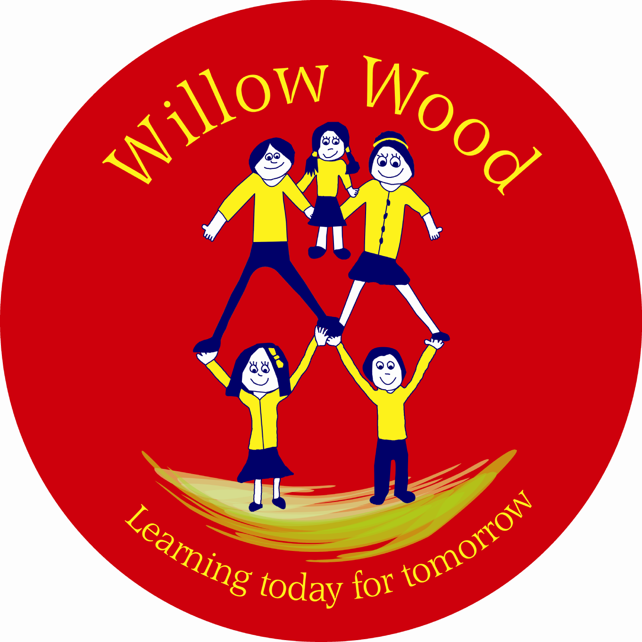

Willow Wood Community Primary School
School Council
Friday 13th October 2017
1.15pm – Staff Room

- Welcome and Attendance

Year 1: Riley, Trudi
Year 2: Ethan, Ebony
Year 3: Felicity, Olivia
Year 4: Mckenzie
Year 5: Jamie, Ryley
Year 6: Olivia, Lillie

Apologies: Reece

Members of staff: Ms Tomlinson, Miss Gregory.

- Training – listening and feedback

Ms Tomlinson delivered some training for the children on how School Council meetings take place. How to feed the information back to classes and how to listen in the meetings.

- Child In Need

The children had a great discussion about how to mark ‘Child in Need’ day this year. There were so many ideas and they were all fantastic. For Friday 17th November they decided on dress up as an animal or wear something spotty and/or crazy hair. A one pound donation is suggested to raise funds for children in need.

- Charity of the year

The children fedback lots of charity names from their classes. A vote took place and overall Macmillan was decided. We will decide shortly on ideas to raise money. The upcoming events organised by the FOWWS were discussed. They are the Bonfire Boogie Friday 10th November and the Christmas Bingo Friday 1st December.

- Photograph permissions for the website
Ms Tomlinson explained that as the School Councillors would be leading lots of school events which would be photographed they needed to check at home if their parent\carer was happy for them to have their photograph on the website. School has records in the school office but it is worth updating now they are Councillors.

- Date of next meeting

Next meeting: Friday 10th November - 1.10pm in the Staff Room.

- Keep asking and involving your classes on all ideas discussed in the meeting.
- Agree a time to feedback with your class teacher.
- Please discuss Fundraising ideas.
- Check photograph permissions at home.

