Learning Project WEEK 2 - Area you live in
Age Range: KS1
Weekly Maths Tasks (Aim to do 1 per day) | Weekly Reading Tasks (Aim to do 1 per day)
- Play on The Mental Maths Train Game - practise adding and subtracting.  - Recognise the place value for numbers up to 99 in this place value basketball game.  - Create a card game that is based around making number pairs to twenty that can then be played as a family.  - Identify shapes and finish the patterns in this online game. Can any of these shapes be found around the house? How many of each shape can be found?  - Write the numbers 20 - 50 in words and digits  - Work on finding out about fractions check out White Rose Maths for ideas.  - Draw a map of your local area. | - Reading a variety of books at home. Your child could share a book everyday. This can be reading a book aloud everyday or sharing a book with an adult.  - Listen to a story read: https://www.storylineonline.net/  - Watch Newsround and find out what is happening in the world. What did you find out? Is there anything you need help understanding?  - Read a book by our author Roald Dahl and check out Twinkl for loads of activities.
Weekly Phonics/Spellings  Tasks (Aim to do 1 per day) | Weekly Writing Tasks (Aim to do 1 per day)
- Daily phonics - Ask your child to practice their sounds and blend words. Interactive games found on link below.  - Phonics play  - Top Marks  - Spelling  - Spell the days of the week  - Spell common exception words  - Spelling City  - Practice spelling contraction words. Use Spellzone, Twinkl to help. | - Ask your child to Imagine that they live in the opposite house. What would they see? Write sentences using a variety of suffixes - ing and adjectives.  - Write your address: Discuss with your child. Do they know who delivers the post? Share a letter with them and explore the envelope from the front and back. Can they see any numbers on the front or back of the envelope? What do they mean? Who is the letter addressed to? Ask your child to write their address on the envelope. Discuss the postcode and any capital letters?  - Well known addresses: Discuss with your child any well-known addresses of book characters/famous people/ historical figures they may know? e.g. 10 Downing Street, The Post Office, Isle of Struay Katie Morag. This Powerpoint may help.  - Write a letter to a person you haven’t seen for a while.
Learning Project - to be done throughout the week: Where do you live?
The project this week aims to provide opportunities for your child to learn more about the area in which they live. Learning may focus on your local area, famous people, key landmarks and links to your city.

To develop knowledge of the location of significant places:
Ask your child to look at where they live. What can they see outside the window in the front of their house? At the back of their house? What could they find near them? Find a map and see if they can find Winsford. Do they know the name of their street? Can they create a street sign with their street name?
Choose a place you would like to visit and create a fact file/poster on that place.

My address: Support your child to find out your address.Can they find the number on your door? Can they write the number in digits and words?. Ask them to try writing the number using crayons and paint.
Can they write a postcard or letter to a teacher at school? They could tell their teacher about where they live and things about their local area.

My house: Discuss with your child what their house looks like inside and outside? How many bedrooms does it have? Who has the biggest bedroom? Who has the smallest? Ask them to look outside their window and see if they can spot a house different to their own.
Can they draw their house? How many windows at the front? How many windows at the back? Do you have one door or two? In a special bag - could you (with adult support) place things that make it your home? Why would you pick those items?

Draw a picture of your street. Support your child to take a look at the street and buildings around where they live. Encourage them to think about the shape of the buildings.

Shape hunt: Take your child on a shape hunt around their house and garden. Look at the different shapes of the windows, doors, and houses. Can they name them? Are they 2D or 3D shapes?
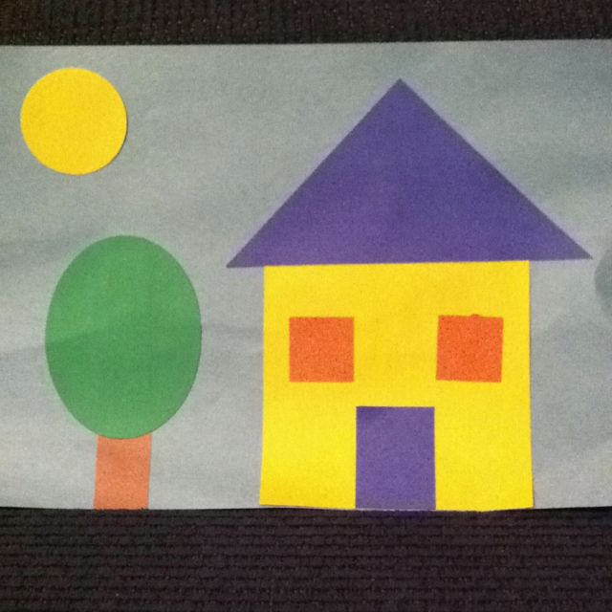
Ask them to create a picture of their house or street.

Name the shape: Place some 2D or 3D shapes into a bag and play the game ‘Can you name the shape?’ You will need a partner to play this game. One partner has a shape from the shape bag and they stand back to back. The partner with the shape describes it to their partner who has to try and draw it.How many do you know?

Find you house on ‘Google maps’.
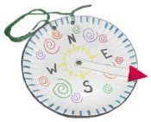
Search for your house on the street? Can you find some of the places you visit.

Compass: Make a compass. Do you know what the different compass points mean? Can you label the points? Can you write a set of directions to get from your house to another local place. Think about using compass directions.

Create a passport: create an individual passport to show your own information about where you live. Discuss the use of a Passport. What is a passport? What information does it contain? What does a passport allow you to do? Can you find a real life passport? Do you have one?
Flag: Here is the British flag. What do you think the flag represents? Can you design your own flag for your local area? What could you add? What would they mean to you?

Design a cottage - Compare how a cottage is different to your house. Can you make a model of your house and a cottage?

Create a song about ‘Where you live’ - Can you add your address in your song?

Can you find the UK on the map? Can you name the countries? Why do you think the Countries begin with a capital letter? This song may help.
Additional learning resources parents may wish to engage with
Classroom Secrets Learning Packs - These packs are split into different year groups and include activities linked to reading, writing, maths and practical ideas you can do around the home.
Twinkl - to access these resources click on the link and sign up using your own email address and creating your own password. Use the offer code UKTWINKLHELPS.
Headteacherchat - This is a blog that has links to various learning platforms. Lots of these are free to access.
#TheLearningProjects

