Reception Home Learning Suggestions Week Beginning 8th June 2020
 | Reading and stories | Phonics, reading and writing | Maths skills | Other
Monday | Watch Superworm  https://www.youtube.com/watch?v=7Jnk3XApKBg  Listen to your child read for 10 mins. Oxford owl or a book from home  https://home.oxfordowl.co.uk/ | Watch Phonics session 7  https://www.youtube.com/watch?v=yVsmYlNXU-k  Super sentence – can you write a sentence about this picture?  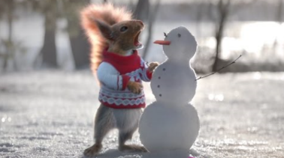 | https://wrm-13b48.kxcdn.com/wp-content/uploads/2020/05/Day-1-Superworm.pdf  Can you continue the pattern?  Can you make your own mini beast pattern?  Take this further by using different sizes of the minibeasts! For example, length or size of your superworms! | Super Moves!  Superworm has many abilities and many moves. How many super moves can you do in 1 minute?
Tuesday | Go on teach your monster read website  https://www.teachyourmonstertoread.com  Watch ‘Yucky worms’  https://www.youtube.com/watch?v=MV3A864z9W0 | Watch Phonics session 8  https://www.youtube.com/watch?v=68FTaim0FOQ  Can you write actions for an insect?  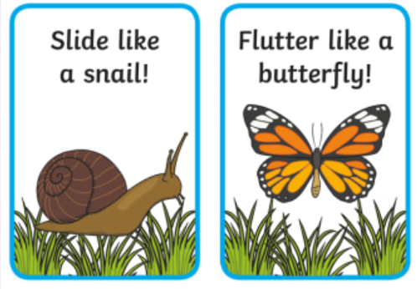 | https://wrm-13b48.kxcdn.com/wp-content/uploads/2020/05/Day-2-Superworm.pdf  Superworm is super Long! But how long is he? Let’s look closely at worms! Let’s draw worms like in “I can only draw worms.”  We can see the worms he draws look a bit like our number  lines at school!  Draw your worms but start at different numbers!  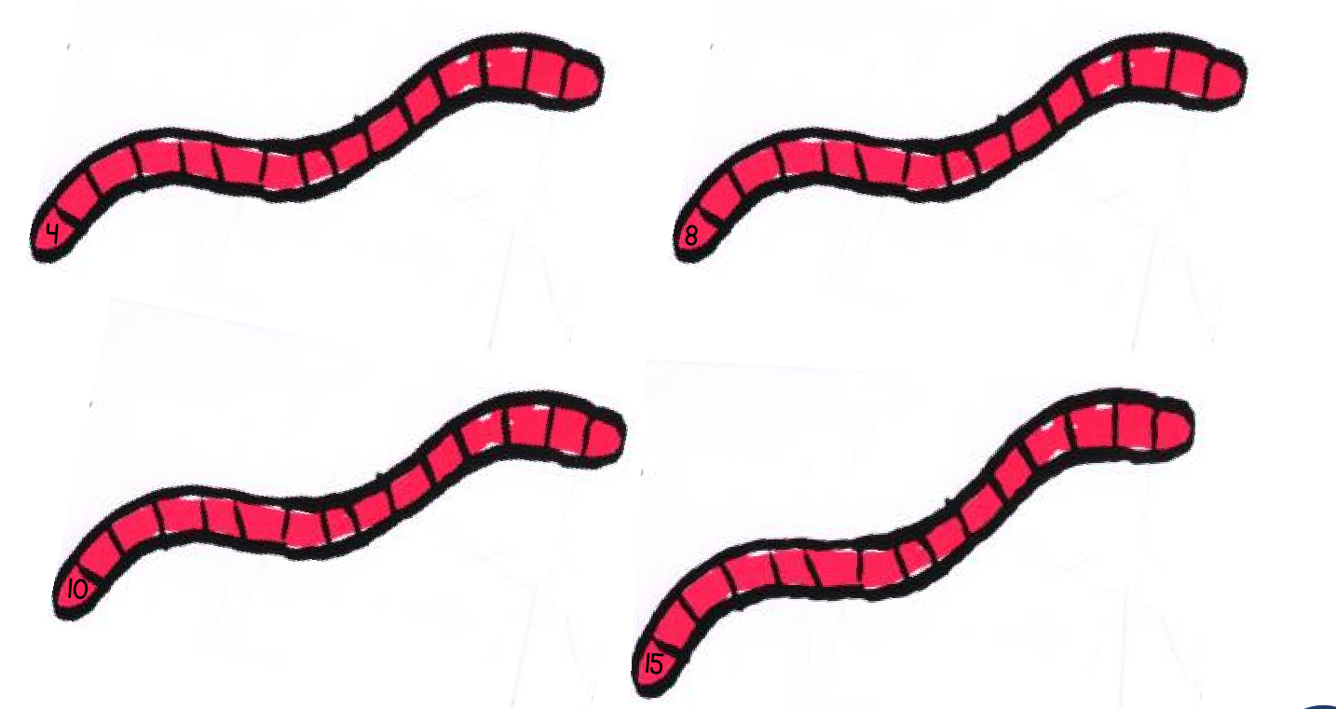 | 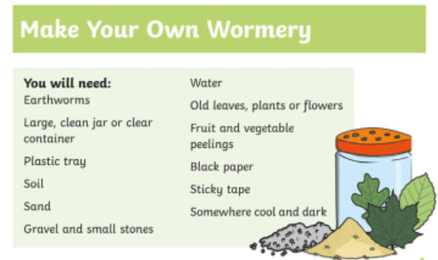  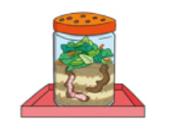
Wednesday | Listen to your child read for 10 mins. Oxford owl or a book from home  https://home.oxfordowl.co.uk/ | Watch Phonics session 9  https://www.youtube.com/watch?v=fbouFmTzBn8  Can you think of some words to describe worms?  Can you put them into a sentence?  The worm is slimy. | https://wrm-13b48.kxcdn.com/wp-content/uploads/2020/05/Day-3-Superworm.pdf  Superworm the skipping rope.  How many skips can you do in 1 minute?  Can a grown up time you? Check your counting! How else can you move your body like Superworm. Can you hula hoop for 1 minute?  Can you use your body as a swing  – swing your arms?  Can you count 20 of one move  and count it? | Worm Dance  Worms come to the surface when they hear the rain on the ground. Sometimes noises convince them it is raining and to come up. Can you make up your own rain dance to make the worms appear?  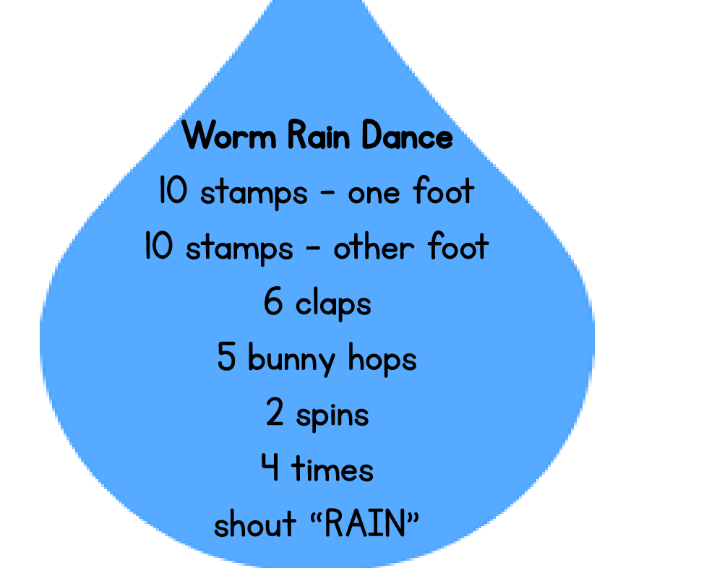
Thursday | Watch ‘Diary of a worm  https://www.youtube.com/watch?v=8h3X2DWzoq4 | Watch Phonics session 10  https://www.youtube.com/watch?v=Et-E9brVTYE  Can you write some facts about worms?  Worms have lots and lots of little rings around their bodies. | https://wrm-13b48.kxcdn.com/wp-content/uploads/2020/05/Day-4-Superworm.pdf  Pick your tin!  Look at the different sizes of these cylinders!  Look at making labels and think about the amount that will be in that tin! If you draw around the old label then you can get the exact size.  Pick your minibeast contents. Are there going to be just one minibeast in a can? Make labels as fancy as you want!  (Grown ups you might want to mark the tin with what is really in it!)  Then go shopping and combine your tins of yuck!  How many minibeasts would I have if I had a tin of my caterpillars and a tin of slugs?  What about half a tin of worms and a tin of slugs? Look at different combinations.  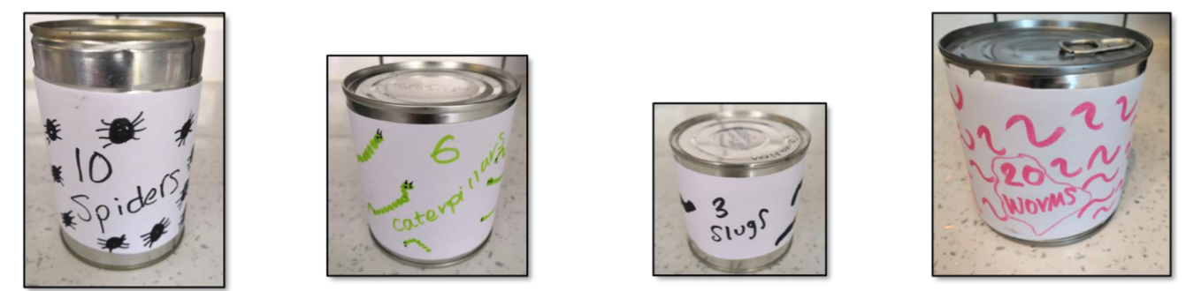 | Can you make your own mini beast hotel?
Friday | Go on teach your monster read website  https://www.teachyourmonstertoread.com | Practise Phase 3 tricky words https://youtu.be/R087lYrRpgY  Super sentence | https://wrm-13b48.kxcdn.com/wp-content/uploads/2020/05/Day-5-Superworm.pdf  Exploring Length  Get together your own collection of worms and see if you can cut them to different lengths. Talk about the lengths and even measure with a ruler or tape measure. Of course we are not going to cut real worms!  Grown ups cook some spaghetti until almost cooked and then rinse under cold water. You can add food colouring to make them any colour you want if you want fancy worms!  You now have ready made worms to cut.  (You can use string, dough or wool if you don’t have spaghetti.) Can you order them in length?  What is your longest worm as long as in your house? What is your shortest worm as long as? | Make you own worm using pasta and string.  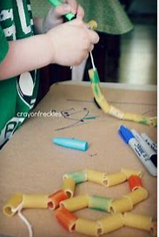
Please remember that these activities are suggestions only. Do not feel under pressure to complete all of these – you could pick and choose, repeat your favourites and definitely introduce your own! Whatever you get up to, please send us your photos, videos and messages via email. Naomi.coates@willowwood.cheshire.sch.uk.
Please keep yourselves happy and safe!
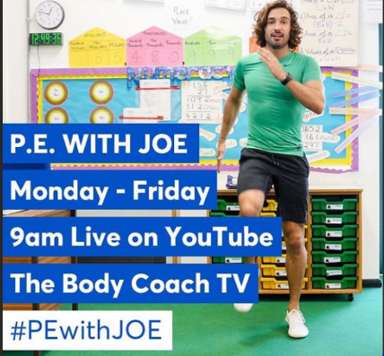
Keeping fit is really important for our health but it also makes us feel great. We know how much you love our daily wake and shake in Reception so why don’t you try P.E with Joe Wicks live on YouTube to start off your day!

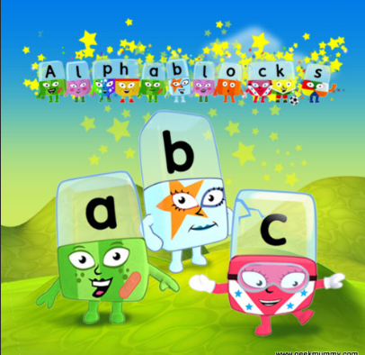
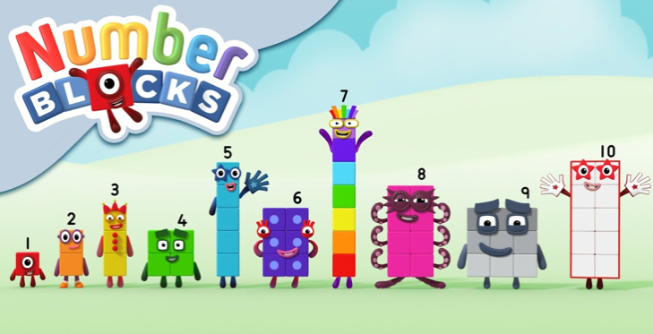
Remember these? Why not watch a few episodes to help with your numbers and phonics? Both programmes can be found on bbc iplayer.

Monday maths – continue the pattern
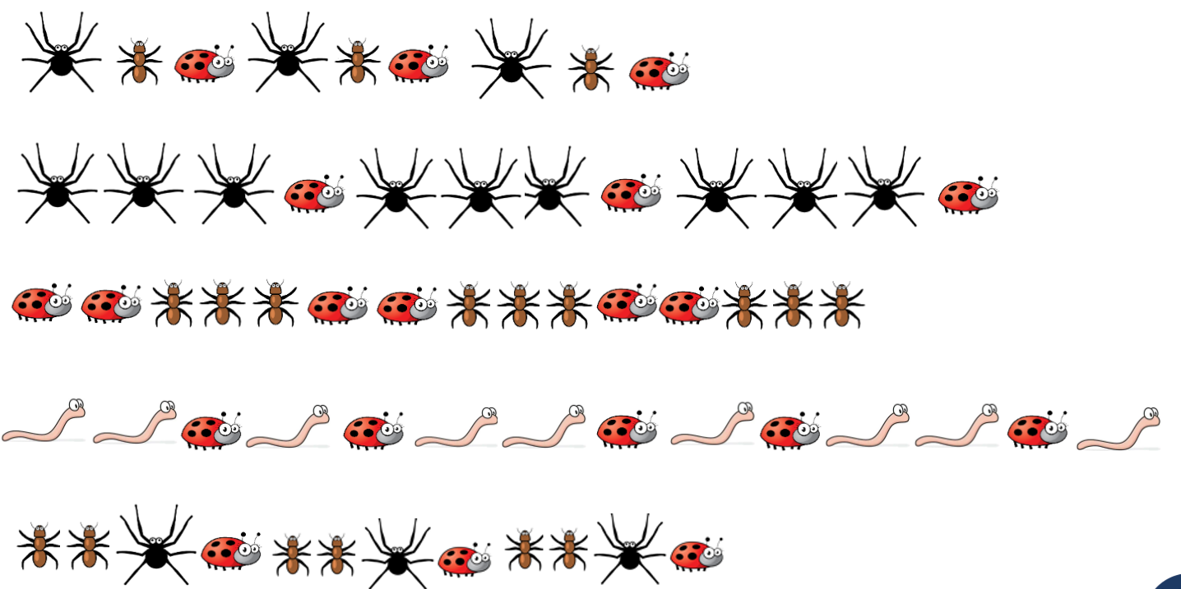

Home Learning 8th June
Super Sentences
Can you write a sentence to go with these pictures? Remember to use your super phonics to help sound out those words.
