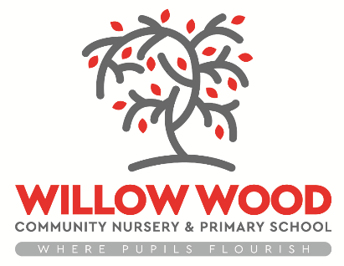

Willow Wood Community Nursery and Primary School

Remote Learning Overview
Offer applicable from January 5th 2021

Nursery
Following government announcements, nursery will remain open to our children. Those choosing not to attend the provision will be able to access our home learning via Google Classrooms.
Reception
Children will be able to access their Remote Learning via Google Classrooms. Each pupil will have a login and password
There will be daily message from the class teacher detailing what has been uploaded for the children to complete.
All lessons will be taught through a recorded video by the teacher, or a video link to the learning activity. There may also be sheets for the children to access. Work completed by our children should be submitted to the school via Tapestry.

Years 1- 6
Every pupil can now access Google Classroom. Each day, their class teacher will upload and assign work that matches the learning that would normally take place in school. Across the period of the lockdown (until at least half term) children will be able to access a full and broad curriculum. Lessons will normally be delivered via a video and will link to an activity for the children to complete. The children should ‘turn in’ their work at the end of each day. Children can access the work at any point during the day, to suit their own home circumstances. Teachers will offer regular feedback to the children, using Google Classroom.

All classes
- Teachers will be available throughout the day to answer questions and provide feedback. This will be done through the platform mentioned above
- Additional activities will be utilised throughout the week such as TT Rockstars, Oxford Owls, Big Cat Reading, BBC Bitesize etc.
- In some cases, teachers may read a class throughout the week
- As the term progresses, more activities and tasks will be introduced such assemblies, fun family tasks etc.
- PSHE well-being focuses, as well as online safeguarding will be included every week in different ways.

