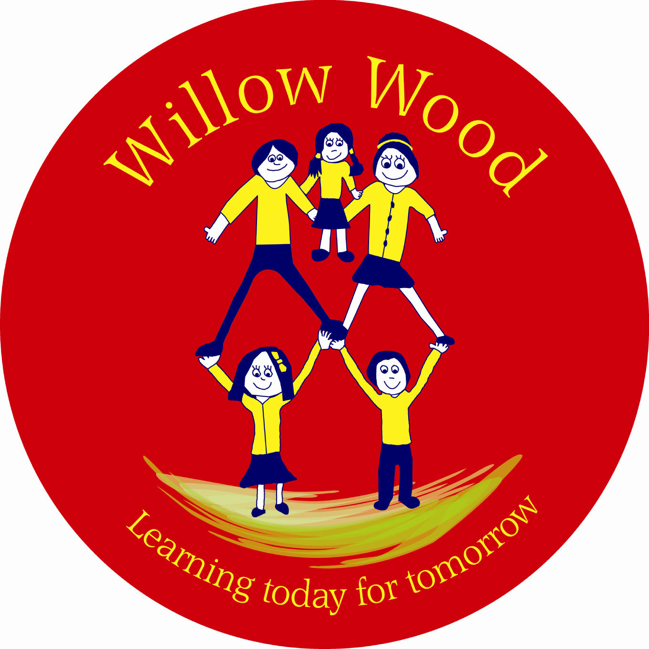

Willow Wood Community Primary School
School Council
Friday 21st November 2014
1.05pm – Community Room in Sunshine Building

- Welcome and Attendance

Year 1: Rose, Hope
Year 2: Shauna, Lauren
Year 3: Mia, Lexie
Year 4: Ethan
Year 5: Lauri, Kevin
Year 6: Sophie, Daniel

Members of staff: Ms Tomlinson

Apologies: Laila (Y6) & Millie (Y4) (representing Willow Wood in Basketball tournament).

Matters Arising

Pudsey Bear Fun Day
Mia reported that friends in her class enjoyed the Pudsey Bear Fun Day and thanked School Councillors for organising this event. School Councillors wanted to know how much money was raised in total. Ethan to ask Mrs Smith and report back.

Open Morning
School Councillors reported that they had enjoyed walking around school with visitors at the open morning this week. They had tried to make conversation, share information and answer questions about their school. They felt proud to be School Councillors and of their school.

Curriculum Consultation
Councillors discussed what the curriculum is and decided, “Everything we learn and do at Willow Wood.” They made a mind map of the current curriculum at school. It was obvious that children covered a wide curriculum, which they enjoyed.

Next the School Council members looked at special events that happen in different year groups for example Y6 going on an outdoor adventurous activities residential.

Ms Tomlinson asked Councillors to discuss the curriculum with their Class Councils and to gather feedback about things that they would like to do learn that could be added to the curriculum. She explained that the hope was to develop a, ‘Pledge for Learners’ for the pupils at Willow Wood Community Primary School, which would give the children the learning experiences they wanted and needed to help them be fantastic learners and achieve well.

Next meeting: Friday 5th December 2014 at 1:10pm in the Community Room in the Sunshine Building – Mrs Stretton, Chair of Governors, will be meeting with members of the School Council to do some work around Vision and Values for Willow Wood.
Next Actions:

Talk to your Class Council about the curriculum. Ask them for feedback.
What would the children like to learn and do at Willow Wood Community Primary School to help them to achieve well?
What would they like to have in a’ Pledge for Learners’ in each year group, to build a great learning journey across our school?

