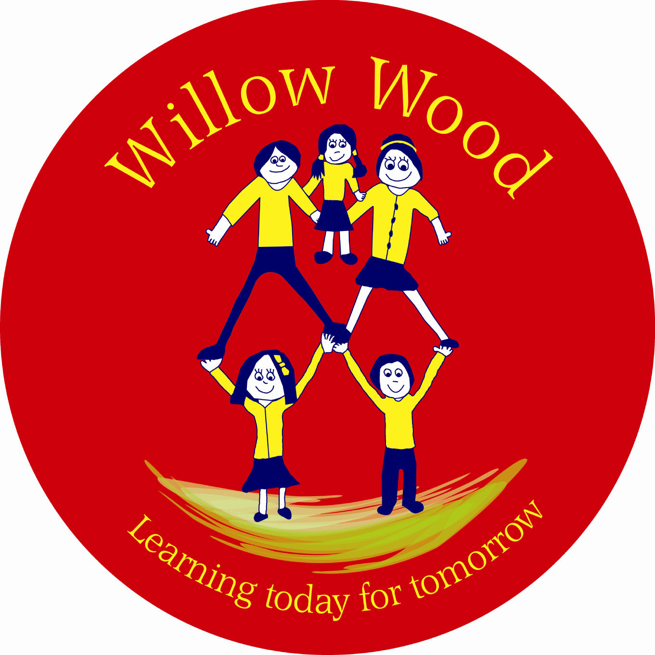
Willow Wood Community Primary School

Bradbury Road
Winsford
Cheshire
CW7 3HN

E-mail: head@willowwood.cheshire.sch.uk

Headteacher: Susan Tomlinson Tel: 01606 593896 Fax: 01606 595400

17 December 2014

Dear Parents/Carers,

FAMILY CHRISTMAS CHALLENGE
The School Council has recently been working with Mrs Stretton, Chair of Governors, to revisit the Vision and Values of Willow Wood.
Now it is the turn of all our pupils and their families!
Our ‘Vision’ is about how we see the school in the future. What would Willow Wood Community Primary School look and feel like when it is great?
When asked what the School Council thought of ‘Values’ they agreed that it was important to make everyone feel valued. We should treat others how we like to be treated so that each of us feels safe, secure, positive, eager to learn, inspired and brave enough to share our ideas.
The group felt proud to be part of Willow Wood. They were empowered and felt able to do things, saying thank you to one another made them feel appreciated. We all wanted to feel needed – achieving things together made us happy.
The School Council had so many ways of describing their experiences at Willow Wood that they started working on acrostics. Acrostic involves using each letter of a chosen word as the beginning of another word, which relates to or describes it.
The group came up with some excellent examples:
SCHOOL – Sharing, Caring, Happy, Opinions, Optimistic, Learning
RESPECT – Recognised, Energetic, Safe, Proud, Enlightened, Careful, Targets
PRIDE – Proud, Reliable, Interested, Determined, Exciting

As a result of the success of the session School Council decided that it would be fun to ask everyone to take part in an Acrostic Christmas Challenge during the Christmas break, with family and friends. Results from the challenge could be collected by the School Council and a selection could be published on the school website.
Please take part by adding your ideas below and returning to school by FRIDAY 9 JANUARY 2015.

Thank you

L. Newton
Chair of School Council

……………………………………………………………………………………………………………….

Willow Wood Community Primary School

FAMILY CHRISTMAS CHALLENGE – Vision & Values Acrostic

Thank you for your contribution.

Name of Child ………………………………………….

Class …………………………………………………….

