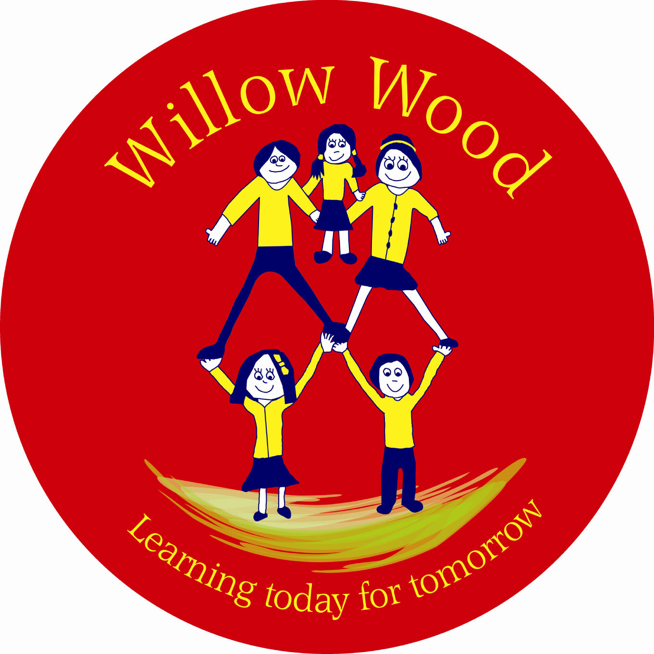

Willow Wood Community Primary School
School Council
Friday 5th June 2015
1.10pm – Community Room in Sunshine Building

- Welcome and Attendance

Year 1: Rose, Morgan
Year 2: Shauna & Lauren
Year 3: Mia, Lexi
Year 4: Ethan, Millie
Year 5: Lauri, Shane
Year 6: Sophie, Laila

Members of staff: Ms Tomlinson & Mrs Cook

Apologies: Daniel

Lauri, Chairperson opened the meeting.

- Minutes & Matters Arising

There were no matters arising that weren’t on the agenda.

- Review School Curriculum Pledges

School Councillors worked in pairs to look through the Y2, Y3 and Y4 Curriculum Pledges. Ms Tomlinson reminded School Councillors that a curriculum pledge is about the knowledge skills and attributes as well as the experiences and visitors that our school promises to provide for our children.
The pledges were agreed for Y2, Y3 and Y4. Y5 and Y6 pledges will be reviewed at the next meeting.

- Curriculum Celebration

The School Councillors discussed a celebration to share the work on the curriculum with parents and other members of the community. They were asked to go back to their Class Councils to gather ideas.

Meeting closed at 2.00pm

Next meeting: Friday 26th June at 1:10pm in the Community Room in the Sunshine Building

Next Actions:

Remember to collect ideas from your Class Councils for a Curriculum Celebration.

