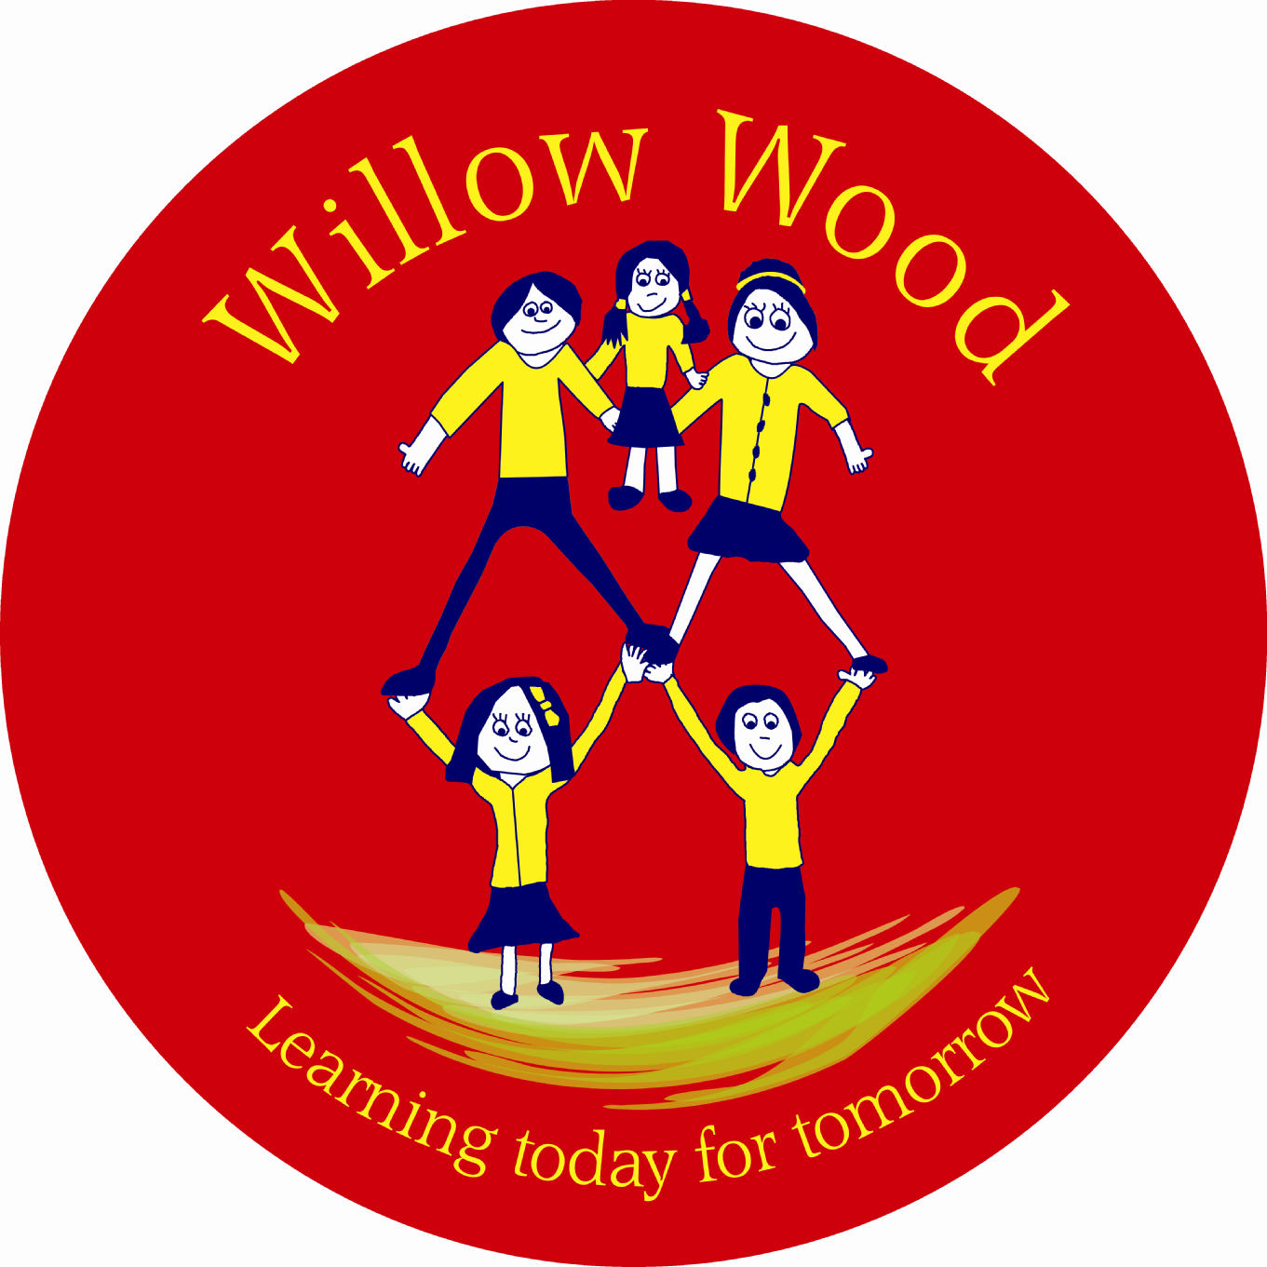

Willow Wood Community Primary School
School Council
Friday 26th June 2015
1.10pm – Community Room in Sunshine Building

- Welcome and Attendance

Year 1: Rose, Morgan
Year 2: Shauna & Lauren
Year 3: Mia, Lexi
Year 4: Connor W, Lucy
Year 5: Shane
Year 6: Sophie, Laila

Members of staff: Ms Tomlinson & Mrs Cook

Apologies: Lexi, Ethan, Millie, Lauri (representing school at sporting event)
Sophie & Laila (working with Leftwich High School as part of transition to Y7)

- Minutes & Matters Arising

There were no matters arising that weren’t on the agenda.

- Review School Curriculum Pledges

School Councillors worked through the Y4, and Y5 Curriculum Pledges. Ms Tomlinson reminded School Councillors that a curriculum pledge is about the knowledge skills and attributes as well as the experiences and visitors that our school promises to provide for our children.
The pledges were agreed for Y4 and Y5. Y6 pledge will be agreed separately with Y6.

- Curriculum Celebration

The School Councillors discussed ideas for sharing the work they have led in school on the curriculum. They want everyone to know what the Willow Wood curriculum is all about, including parents and friends.

The following ideas were discussed:
An exhibition
Share Floor Books and topic books
Share lessons
Let parents visit every classroom to see the curriculum through displays etc
Set a quiz like when Y6 went orienteering with the answers in each classroom

The School Councillors decided to hold an event called:

“Curriculum goes Wild at Willow Wood!”

Each Councillor needs to set at least 2 questions about the curriculum they have studied this year that can be answered from information in the classroom. A ‘Curriculum Challenge Quiz” will be set, pupils and parents will visit every class to get the answers. School Councillors will collect and mark the quiz and there will be good prizes.

Mrs Cook and Ms Tomlinson will share with staff and get feedback on when the event should take place and any fine-tuning for health and safety purposes.

- WEP Logos

School Councillors will judge these at their next meeting. Therefore they need to bring the best three from their class to enter into the whole school competition. The best three from the whole school will be forwarded to the WEP competition.

Meeting closed at 2.00pm

Next meeting: Friday 10th July at 1:10pm in the Community Room in the Sunshine Building
WEP Logos to be judged
Quiz questions to be set

Next Actions:

Remember to judge the top three WEP logos from your class and bring them to the next meeting so that they can be judged.
Remember to set 2 questions about the curriculum in your classroom and bring to the next meeting.

